RINGS-A000-EUR-Italy-Rome-Legio II Augusta

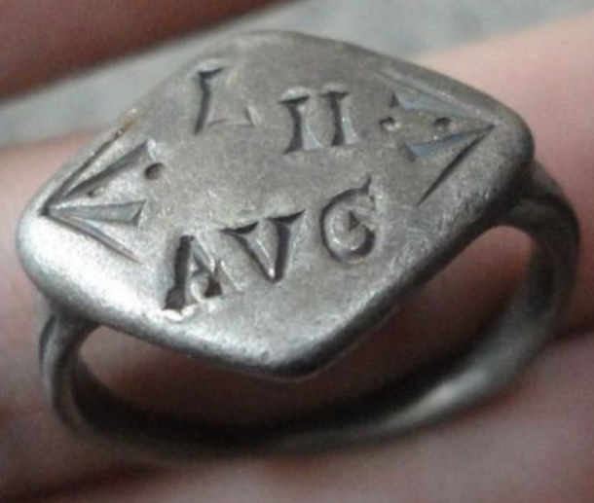 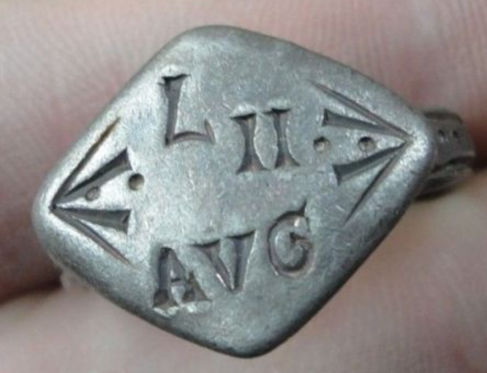

Legio II Augusta

**Legio secunda Augusta ("Augustus' Second Legion") was a legion of the Imperial Roman army that was founded during the late Roman republic.**

INSCRIBED - " AVG - L - II "

EXTREMELY RARE **Roman SENATORIAL LEGIONARY SILVER ring.**

SOLID SILVER - Wearable <> 8.64 grams <>

**<> 22.00mm. = 0.88" Inner diameter <>**